**NAAN MUDHALVAN-IBM(AI) PROJECT**

IBM AL 101 ARTIFICIAL INTELLIGENCE-GROUP 1(TEAM 5)

**PROJECT TITLE:**

CREATE A CHATBOT USING PYTHON

**TEAM MEMBERS:**

* DAYANIDHI N(reg no:110321106007)
* CHIRANJEEVI C(reg no:110321106007)
* CHOLA PRASAD D A(reg no:110321106006)
* ARIVUMATHI V(reg no:110321106002)
* BHARATHKUMAR N(reg no:110321106003)

**Phase 2: Innovation**

**ABSTRACT:**

In the rapidly evolving landscape of digital communication and automation, chatbots have emerged as a valuable tool for enhancing user experiences, streamlining customer support, and providing efficient information retrieval. This project aims to design and implement a chatbot using Python, a versatile and widely used programming language. The chatbot will be capable of natural language processing, understanding user queries, and providing meaningful responses. By leveraging Python's robust libraries for text processing and machine learning, we will develop a chatbot that adapts and learns from user interactions, ultimately enhancing its conversational abilities and usefulness.

**Introduction:**

This project aims to create a chatbot using Python, one of the most popular and versatile programming languages. Python is well-known for its simplicity and readability, making it an ideal choice for developing chatbots. Python's extensive libraries for natural language processing (NLP) and machine learning will enable us to design a chatbot capable of understanding and responding to user queries in a human-like manner.

The chatbot will be designed to evolve and improve its conversational skills over time, learning from each interaction with users. By implementing techniques such as machine learning and reinforcement learning, it will adapt its responses to better cater to user needs and preferences.

The development of this chatbot will involve multiple stages, from data collection and preprocessing to training and deployment. We will utilize Python's powerful NLP libraries, including NLTK and spaCy, and explore machine learning frameworks such as TensorFlow and scikit-learn to create a chatbot that continuously improves its performance.

This project represents an exciting journey into the world of conversational AI and Python programming. By the end of it, we hope to have a functional chatbot that demonstrates the potential of Python in enhancing human-computer interactions and showcases the power of continuous learning and adaptation in the realm of chatbots.

**Innovative Design for Creating a Python Chatbot**

Designing a chatbot using Python can be innovative and

effective by incorporating cutting-edge technologies and creative problem-solving. Let's explore innovative design elements to solve common problems and make your chatbot stand out:

1.Advanced Natural Language Processing (NLP)

2.Multimodal Interaction

3.Emotion Recognition

4.Personalization

5.Contextual Understanding

6.Predictive Typing

7.IoT Integration

8.Multilingual Support

9.Voice Synthesis

10.Continuous Learning

11.Voice Biometrics

12.Augmented Reality (AR) Integration

13.Blockchain for Data Security

14.Quantum Computing for Speed

15.Ethical AI

16.AI Chatbot Marketplaces

**1.Advanced Natural Language Processing (NLP):**

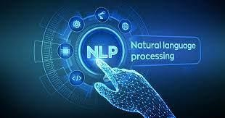

Utilize state-of-the-art NLP models like GPT-3 or BERT to enable your chatbot to understand and generate human-like responses with context and coherence.

**2.Multimodal Interaction:**

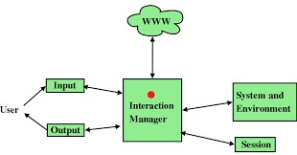

Innovate by allowing the chatbot to process text, images, voice, and even gestures. This expands its capabilities to assist users with a wide range of queries and interaction modes.

**3.Emotion Recognition:**

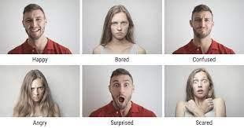

Implement sentiment analysis and emotion

recognition algorithms to gauge the user's emotional state based on text input or voice tone. The chatbot can adapt its responses to provide empathy or assistance accordingly.

**4.Personalization:**

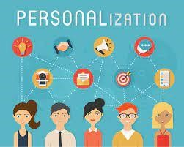

Use machine learning to personalize the

chatbot's responses based on user behavior, preferences, and historical interactions. Consider recommending products, content, or services tailored to individual users.

**5.Contextual Understanding:**

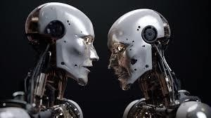

Enhance the chatbot's contextual awareness

by storing and recalling previous interactions. This enables more meaningful and coherent conversations over time, making users feel understood.

**6. Predictive Typing:**

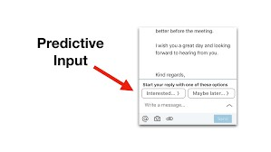

Implement predictive typing suggestions using machine learning models. This feature can assist users in formulating queries faster and with greater accuracy, improving user experience.

**7.IoT Integration:**



Extend the chatbot's functionality by enabling it to

control and interact with Internet of Things (IoT) devices, such as smart home appliances, through voice or text commands.

**8.Multilingual Support:**

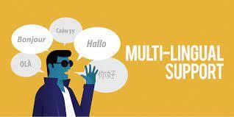

Make your chatbot multilingual to cater to a

global audience. Implement language detection and translation features to facilitate seamless communication in different languages.

**9. Voice Synthesis:**



Develop a natural-sounding voice for your chatbot using textto-speech (TTS) synthesis, enhancing the quality of voice interactions and user engagement.

**10.Continuous Learning:**

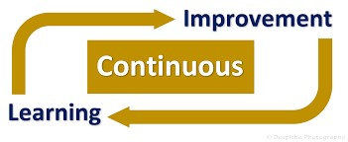

Implement reinforcement learning algorithms to

allow your chatbot to learn and improve its responses over time based on user feedback and interactions.

**11.Voice Biometrics:**



Enhance security by incorporating voice biometric

authentication for sensitive interactions, such as account access or transactions.

**12.Augmented Reality (AR) Integration:**

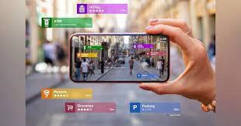

For mobile chatbots, consider integrating AR features

to provide visual assistance, such as overlaying instructions on a user's camera feed.

**13.Blockchain for Data Security:**



Explore blockchain technology to ensure the security

and integrity of user data and chatbot interactions, instilling trust in users.

1. **Quantum Computing for Speed:**

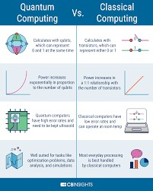

In the future, consider harnessing the power of

quantum computing to make real-time processing and decision-making even faster and more efficient.

1. **Ethical AI:**

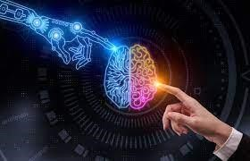

Ensure that your chatbot adheres to ethical AI

principles, respects user privacy, and follows responsible AI practices to gain user trust and compliance with regulations.

**16.AI Chatbot Marketplaces:**

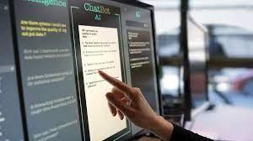

Create a marketplace where users can enhance

their chatbot with AI plugins, allowing for greater customization and functionality, fostering a community of innovation.

By integrating these detailed innovative elements into

your Python chatbot design, you can create a solution that not only addresses specific problems but also offers a truly exceptional user experience.

**let's explore some innovative features for creating a chatbot using Python with sample code for each:**

**1. Sentiment Analysis:**

Implement sentiment analysis to detect and respond to users' emotions.

**Python code:**

from textblob import TextBlob

user_input = input("You: ")

sentiment = TextBlob(user_input).sentiment

if sentiment.polarity > 0:

response = "Bot: That's great to hear!" elif sentiment.polarity < 0: response = "Bot: I'm sorry to hear that." else:

response = "Bot: I see. Please tell me more."

print(response)

1. **Multi-Language Support:**

Create a chatbot that understands and responds in multiple languages.

**Python code:**

from googletrans import Translator

translator = Translator()

user_input = input("You: ")

translated_input = translator.translate(user_input, src='en', dest='fr').text

# Perform chatbot logic based on the translated input # You can add responses in different languages. print(f"Bot (French): {translated_response}")

1. **Voice Recognition:**

Enable voice interactions with the chatbot using a speech recognition library like SpeechRecognition.

**Python code:**

import speech_recognition as sr

recognizer = sr.Recognizer()

with sr.Microphone() as source: print("Say something:") audio = recognizer.listen(source)

user_input = recognizer.recognize_google(audio)

# Process user_input and generate a response

print("Bot:", response)

1. **Personalization:**

Personalize responses based on user data. Here's a simplified example:

Python code:

user_name = input("What's your name? ") user_input = input(f"{user_name}: ")

if "hello" in user_input.lower():

response = f"Bot: Hello, {user_name}!" else:

response = "Bot: I'm here to assist you."

print(response)

1. **Knowledge Graph Integration:**

Connect your chatbot to a knowledge graph (e.g., using RDFLib) for domain-specific information retrieval.

**Python code:**

from rdflib import Graph

g = Graph()

g.parse('your_knowledge_graph.ttl', format='turtle')

user_input = input("You: ")

# Query the knowledge graph based on user_input

# Generate a response using retrieved information

print("Bot:", response)

1. **Image Recognition and Processing:**

Enable the chatbot to understand and respond to image inputs. You can use libraries like OpenCV for image processing and a pre-trained deep learning model for image recognition, such as TensorFlow or PyTorch.

**Python code:**

# Implement image processing and recognition logic here image_input = process_image(user_uploaded_image) response = recognize_image(image_input)

1. **Reinforcement Learning for Conversational AI:**

Train your chatbot using reinforcement learning techniques to optimize its responses based on user feedback over time. Libraries like Rasa can help with RL-based chatbots.

**Python code:**

# Implement reinforcement learning for chatbot training

def reward_model(user_input, bot_response): # Define a reward function based on user satisfaction return reward

# Use RL techniques to improve chatbot responses train_chatbot_with_rl(reward_model)

1. **Contextual Understanding and Dialog Flow:**

Enhance your chatbot's ability to maintain context and engage in more extended conversations by implementing dialog management techniques.

**Python code:**

# Implement context management for multi-turn conversations conversation_history = []

def chat_with_bot(user_input): conversation_history.append(user_input)

# Use conversation_history to understand context and generate responses

response = generate_response(conversation_history) return response

**9. Integration with APIs and Services:**

Connect your chatbot to external APIs and services to provide realtime information or perform specific tasks, like weather updates, booking reservations, or retrieving news.

**Python code:**  import requests

user_input = input("You: ") if "weather" in user_input: response = requests.get('weather_api_url').json() else:

response = "Bot: Sorry, I couldn't find any relevant information."

print("Bot:", response)

1. **Hybrid Models:**

Combine rule-based and machine learning approaches to create a hybrid chatbot that balances predefined responses with learned behavior.

**Python code:**

# Implement a hybrid chatbot that combines rule-based and ML-based responses if user_input in predefined_responses: response = predefined_responses[user_input] else:

response = ml_model.generate_response(user_input)

1. **A/B Testing and Analytics:**

Continuously improve your chatbot by conducting A/B testing with different response generation strategies and monitoring user interactions for analytics.

**Python code:**

# Implement A/B testing for different chatbot response strategies

# Collect and analyze user interaction data for improvements

These features can significantly enhance the capabilities of your chatbot. Depending on the complexity and scale of your project, you may need to use external libraries, APIs, and machine learning frameworks to implement them effectively.